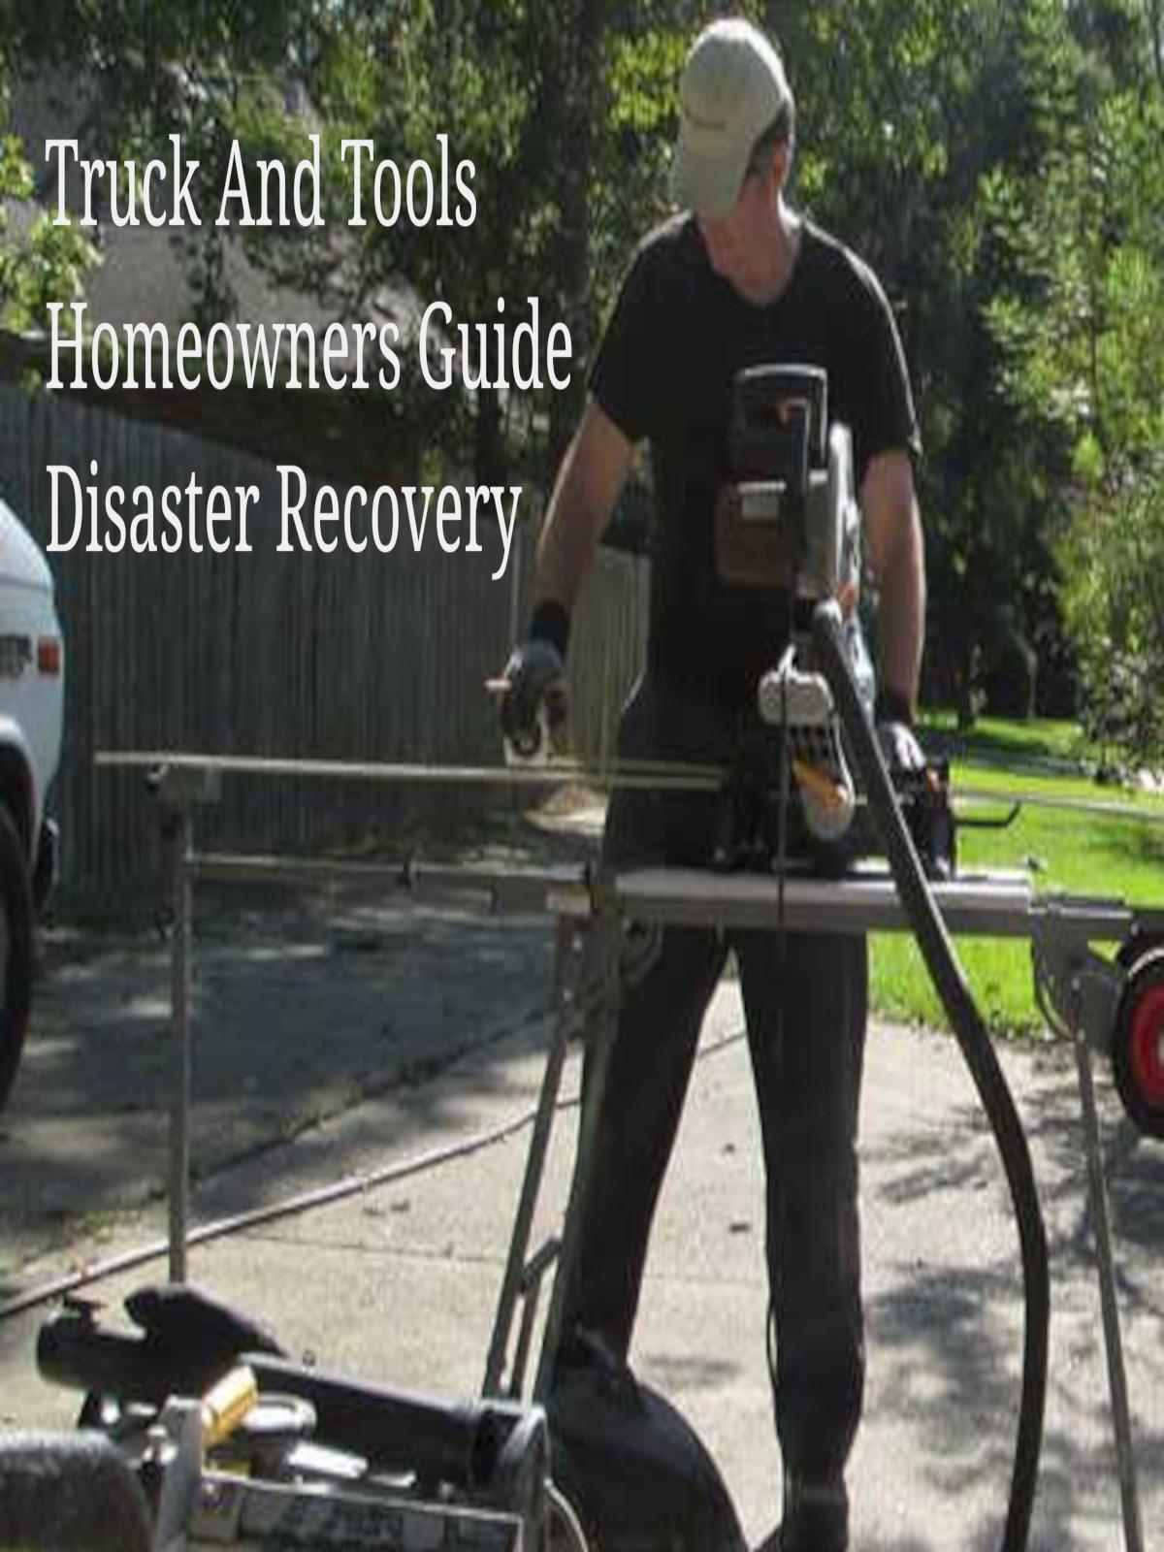

Permits Construction Remodel Room Addition Structural Change

Lets be honest about permits and how we may feel about city officials asking us for more money. It stinks.

Let's not pull any punches.   
  
"You want to add an addition to your home, and you want to do it without increasing your yearly property taxes.   
Your thought process might be on the lines of "If I don't apply for a permit they will never find out about my room addition."  
I can't afford the extra property taxes if they know I added 1300 square feet onto my house by making the back porch part of the main home.   
Why do they want me to pay for a permit anyway? It's just another tax, and I hate paying taxes.   
I'll just skip the whole permitting process and do what I want to do and be done with it. "

...........

You might agree with all of the above, and we are not here to pass any judgement, but we do like sharing things from our neighbors.

We all have different types of neighbors when it comes to permitting.   
Here's a list we put together to match a few of the stories shared by our site's neighbors.   
  
1. Not getting a permit because I'm not paying any more to the city.  
2. Not getting a permit because I am not going to follow any industry standards or any codes.  
3. Not getting a permit because I am not licensed to do the work I will be doing. (non owner)  
4. Not getting a permit because I am not going to allow a city worker to inspect or review my workmanship.

* Why do some neighbors get permits on every project when a permit is required?  
  Maybe it's to insure Quality, Safety, Value.
* Why do we call or look online to our city planners office for information about a project we are about to start?  
  Answer: Time Savings, Money Savings, Building Codes, Permitting Requirements

Neighbor's Story, "The Missing Roofing Material."

When our neighbor was looking to replace their roof, the sub-contractor that provided labor only advised the homeowner to measure the roof and purchase the material from a local orange big box store. The Labor was quoted to be $2,100.00 which sounded like a reasonable labor fee.  
At the big box store our neighbor found many different types of roofing material and didn't really know which ones to purchase. The sales help didn't know anything other than "This is cheaper". The neighbor ended up buying the cheaper roofing material, and the sub-contractor installed it without offering any feedback on the type of materials.   
Later, after a major storm with high winds hit the area, the homeowner was left with missing roofing material. The homeowner called the sub-contractor labor only and asked why the roofing material tore off the roof. The sub-contractor said, "Guess the material was defective," then advised the homeowner to call the orange box store. The store manager asked if a licensed contractor installed the material and quickly passed him on to their 800 customer service center. Next thing you know they are saying you need to contact the manufacturer of the material. You call the manufacturer of the roofing material, and they are very helpful. They lookup your Climatic and Geographic design criteria and find you are in a high wind area and had purchased material not designed for that type of wind. You try to make a stand that the store sold you the materials, and it was true, but from a repair point of view and because you didn't ask your city planners office for a copy of the applicable construction codes and editions, you didn't know you were in a 99 mile per hour wind zone.

You purchased material based on price and not based on building standards for your area. The blame is on you neighbor not the labor, not the manufacturer. But, if you find a local orange box store selling products not rated for your area be sure to make it known.   
(We will share how to make these complaints that lead to change in another article.)

Your roof repair now is twice that amount of savings you made by buying by price and not by advice.

Also by having a permit and listed as the owner contractor your warranty on the correct materials may have been increased with an inspection of your roof.

Neighbor's Story, "Great Job, now move it 3 feet that way."

One of our neighbors built a carport over a concrete slab that was poured to the property border. They found out from another neighbor that it's ok to have a concrete slab to the property line.   
With this in mind the neighbor set out to build a cover for their parking.   
Logical thinking here said if one neighbor says it's ok to pour concrete to the property border why wouldn't it be ok to build a carport cover over that concrete slab?  
The neighbor went online and ordered a $5,000.00 kit complete with DVD on how to install it.   
They drilled the anchor bolt holes, set up the frame and finished that following weekend.   
The city inspector saw the new construction and placed a yellow tag on it pointing out that no permit was issued for this address for this type of construction.   
The neighbor headed down to the planners office to discuss the issue.   
The city planner said it's Ok, you can purchase a permit now, and we wont fine you for building the carport without a permit. The neighbor was relived, it was only going to cost $20.00 to get back into the good graces of the city inspector. But just as the neighbor started to smile the city planer handed the neighbor a copy of city lot setbacks. It appears that the concrete to the property line was to code but any structures other than the main structure has to be set back 3 feet from the property line. The city planner said, "After you pay for your permit you can go back and move your carport cover back away from the property line 3 feet or more. I'll be out to inspect the following week."

Neighbor's Story, "I always hire a licensed, insured, bonded contractor."

A different neighbor that always contracted the work out because they couldn't pick up a hammer without busting a thumb.   
It was time for this neighbor to improve their property by installing a paved driveway which would be a major upgrade compared to the dirt path they called a driveway for years.   
The neighbor called a licensed contractor with a good name Asphalt Paving.   
They did driveways, parking lots, small streets and even concrete driveways according to their information brochure.   
They called the licensed contractor who arrived and quoted a good price. They hired the contractor and as a good neighbor listened to the contractor about the type of driveway they were to get.   
They ended up getting an asphalt driveway which turned out very nice.   
One day the city inspector noticed the black driveway in a sea of concrete white and stained driveways. The inspector placed a notice on the home.   
The shocked homeowner visited the city planner and was handed list of approved materials for driveways within the city limits. I appears Asphalt was not one of the materials. The neighbor contacted the licensed contractor and found how quickly contractors point out their written and signed contract. It was not the responsibility according the State Licensing Board that the contractor know the city requirements for a paved driveway. The contract clearly stated that the material to be used was asphalt, and the homeowner was at fault for ordering the wrong material. Nothing actually happened, but it shows even a licensed contractor without a permit inspection can make a very costly mistake.

Neighbor's Story, "I used all basic materials acceptable, and the fence was below the height requiring a permit."

One neighbor researched the requirements of installing a property border fence. They found that any fence height 4 feet or less did not require a permit. They also found that the city listed wood or metal as proper building material. The neighbor concreted bent pieces of metal into the ground, cutting the tops at 4 feet on the property. Once the bent and mangled fence posts were installed, bailing wire was placed between the posts and then scrap pieces of cut fencing material added like lattice work between the mangled posts and attached to the bailing wire.   
After the metal work and concrete work was finished the neighbor collected industrial skid palettes and leaned them against the wired metal fencing. Once the wood and metal work were complete, they stopped all weeding on the property line to allow weeds to grow over all the material and now looks a like a weed bush.   
No permit needed, no city inspection, value of neighbors home and value of bordering home decreased due to the type of property border fencing.

Most cities do have standards of craftsmanship, and it's up to the city to inspect your work. But without a permit you often get to get away with anything as long as nothing is noticed.

To combat the scrap metal and wood fence neighbor, the bordering neighbors designed an 8 foot fence on the same property border and lined it with scrap from mufflers to appliances. The top was wired to allow AOL CD's to hang and flash in the wind. The city did notice, inspected and ordered all the fencing material removed from both properties. Fined them both, and no fence has ever gone back up.

Some cities and states have special code for some major trades.   
Mechanical meaning HVAC for the most part.   
Plumbing which focuses on sewer lines.   
Electrical especially the service head to meter and first pullout.

Neighbor's Story, "Purchased wholesale, flooded home to flip for the price of the land."

A new neighbor which was actually an investor in properties started to renovate a heavily damaged home. The major damage was the foundation, but the city didn't shut things down until they noticed they were pouring concrete over sewer pipes not installed by a state licensed plumber. This neighbor didn't know that plumbing, especially sewer lines, are to be completed by state licensed plumbers and inspected by the city. The city inspector visited the project site because they did purchase a remodeling permit. When they saw foundation work and sewer pipe work without a proper permit and licensed plumber, they shut the project down. This is a very costly mistake for investors flipping homes.   
By ignoring permitting guidelines requiring specialty trades, they sabotaged their own flipping fortune.

Neighbor's Story, "Hot tub for Four on the Floor"

Our last neighbor in our most treasured of neighbors hired a person to install a hot tub.   
This was a very large 4 person tub.   
The location for the installation was inside the home. The home was of an old design and actually was built out over the years. Foundation work on the main home was stem wall with poured concrete over fill. The outer rooms were elevated floor on pier and beam.   
The hot tub was to be place over one of the oldest pier and beam sections.   
Several things were wrong with this project, and no permit was requested.  
The neighbor hired a "I Got A Guy" from a friend of a friend over social media.   
The guy claimed "No Job To Big or To Small" online.   
The day he arrived, he told the owner the price of the tub and agreed to pick it up and deliver it.   
He also wanted time and material in advance for the installation of this tub.   
The neighbor paid him, he delivered the tub and was never seen again.   
Here we have the friend of a friend over social media issue and the lack of information social media has to offer. If our neighbor would have known that a licensed plumber and electrician would be required, they may have called a licensed tradesman and had the tub installed that same week. But because this is a "I Got a Guy" referral, and that guy couldn't read or didn't know to read city codes regarding hot tubs, the neighbor is out of money and out of hot tub fun.

In conclusion, you can complain all day long about paying extra for permits, but when you find permits may actually offer you some insights to what is required, you may say the $20 to $70 for a hot tub permit was nothing compared to what you learned from your city planners office on safety codes and state laws.

Here are some solid reasons why you may never want to request a permit.   
Remember the Asphalt Company? Well, it's in their best interest not to request a permit and to tell you a permit is not required because of this law we have here in Louisiana.

§2171.1. Inspection of local building permits  
Each month the board or its staff shall inspect the list of residential building permits issued by each local building permit official in this state to ensure that no person is working as a residential building contractor without an active license.  
Acts 2001, No. 802, §1.  
<https://legis.la.gov/Legis/law.aspx?d=93594>

Copyright 2023 TruckAndTools.Com All Rights Reserved.   
Author: Writers Pool   
[Original post location](https://www.truckandtools.com/projects/workshop.asp?gdyk=5)   
Published: 10-23-2017 Revised: 3-1-2023   
[Make a contribution](https://www.truckandtools.com/contribute/default.asp)   
[TruckAndTools.Com](https://www.truckandtools.com/)