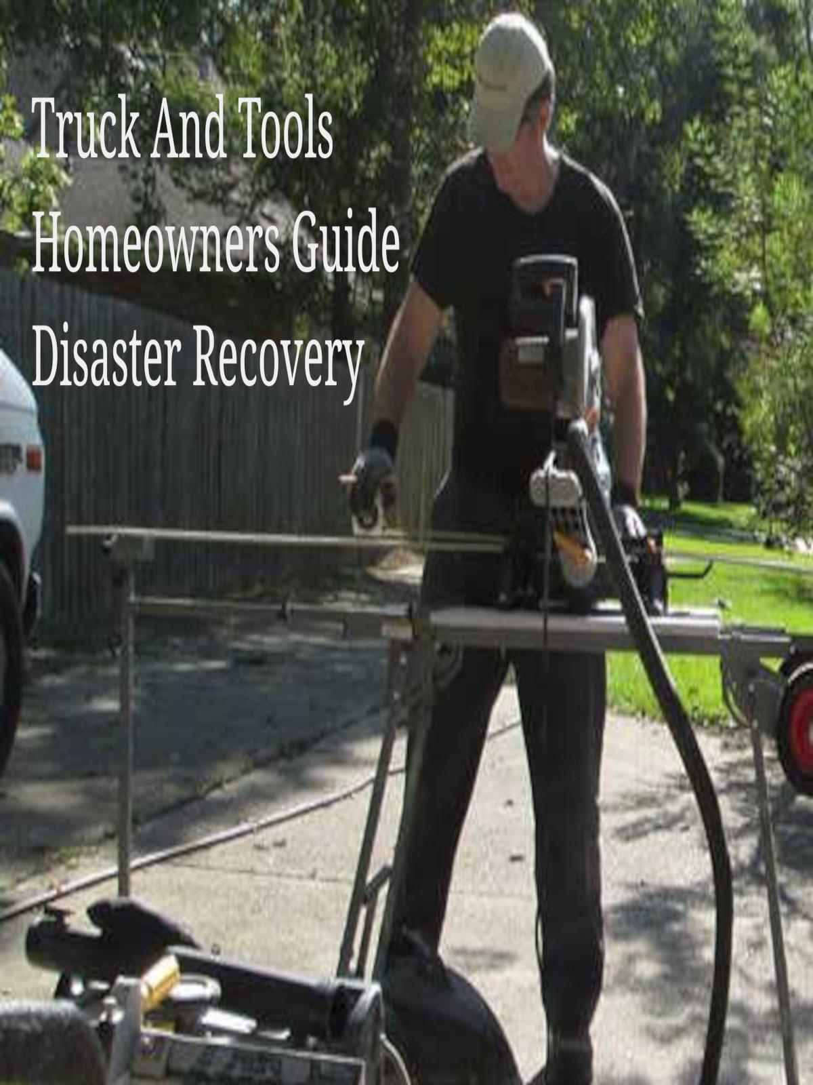

How to determine if the home or property you are looking to buy has been flooded

Do you know what resources are available to you as the buyer of the property or home?

From experience in flood zones you'll like to know most listing agents will not show the words "Flooded" unless they are selling a home we call "Flooded and Gutted".

From our experience with flooded properties with homes and structures on them we read words like "Newly Renovated", "Newly Remodeled", "Completely Refinished" and more.

What the listing realtors are not saying is that the home flooded and they had to rebuild.

So how do you find out if a home was flooded?

(We will update this post when more government agencies send us links to their flooded homes list.)

In the state of Louisiana we have what is called a "INFORMATIONAL STATEMENT FOR LOUISIANA RESIDENTIAL PROPERTY DISCLOSURE"

This started in 2003, what it offers buyers is information about the house from what the legal seller feels like disclosing to you.

Can this disclosure be trusted as to be 100% true?

Copied from Louisiana RS 9:3198 [legis.la.gov/Legis/law.aspx?d=181357](https://legis.la.gov/Legis/law.aspx?d=181357)

E. A seller shall not be liable for any error, inaccuracy, or omission of any information required to be delivered to the purchaser in a property disclosure document if either of the following conditions exists:  
(1) The error, inaccuracy, or omission was not a willful misrepresentation according to the best of the seller's information, knowledge, and belief.  
(2) The error, inaccuracy, or omission was based on information provided by a public body or by another person with a professional license or special knowledge who provided a written or oral report or opinion that the seller reasonably believed to be correct and which was transmitted by the seller to the purchaser.

One example and issue may come from a realtor advising a seller what to do.   
Let's work with simple examples of what may or may not happen in your life.

Questions flooded homeowners ask:

Are you in a flood zone? (Look it up!) <https://msc.fema.gov/portal/home>

1. My home was flooded, I have completely repaired and upgraded the parts of the home that was flooded. Is the home still to be listed as flooded or because I fixed the flood damage can I say it wasn't flooded?

2. My home was flooded and the property flooded. I opted to demolish the home and build a new home instead of repairing the old flooded home. Is the new home to be listed as flooded even if it wasn't flooded because it is new?

If your Realtor states the home or property is not in a flood zone be sure to visit the "[How to read FIRM Maps](https://www.truckandtools.com/disaster/fema.asp?gdyk=3)" posted here. It will show you how to confirm that a property is not in a flood zone.

If your Realtor states that the home is in a flood zone and it's a "Flood Zone X" be sure to research if this flood zone X is shaded in the FIRM or unshaded. Unshaded does not mandate that you have flood insurance. But, it doesn't mean that the property was not flooded.

Best way to start with checking your property is to ask your Realtor.   
Many will tell you the truth while some will avoid the question or tell you it's a zone that doesn't require flood insurance. Not requiring flood insurance and did the property flood are two different questions. It has been reported that 25% of flood calms come from home and property owners outside the flood zone.

Ask the neighbors. You need to meet the neighbors anyway, so why not make it an information gathering event. Ask about other neighbors and weather patterns from flood to snow. Ask if the trees are often uprooted or if the soil remains wet for days after each rain. Drainage is a good conversation starter for anyone in the state.

Visit the City Office and request the FEMA Notice Of Substantial Damage report.

FIRM, check the maps, you will see many homes are close if not in the shaded areas. If they are in a shaded area you next steps will be simple.   
1. Ask for a certificate of elevation. This will give you all the information you need to know if the property is above Base Flood Elevation or below. It will show you elevations for the foundation and the land around your home. It's important to have this information when you start researching your chances of flooding due to intense rain.  
  
2. Visit the [National Weather Service Advanced Hydrologic Prediction Service](http://water.weather.gov/ahps2/hydrograph.php?wfo=LIX&;;gage=DENL1). Or better know to many as the "River Stage Gauge" page for short. Find the location of your nearest river stage gauge. Look for "Historical Crests" and write them down. You will need to know the dates so when you talk to people you can ask them if they lived in the area during those dates. If they did not, they didn't get a first hand view of the flood. Ask someone else about it.

Example: 1973 water was within 2 city blocks. 1983 Water was within 1 city block. 2016 water was in the home. These were all 100 year or 1% floods.

3. Use Google Earth to view elevation changes. From the river stage measurement draw a path down roads and across properties to see elevation changes. Keep drawing paths until you completely cover the areas of interest. After you have your Google Earth app covered with paths, right click on the path and click on "Elevation". You will see a terrain simulation appear below your map. Use this to identify low areas and flood paths. Look at were your property is located and measure all 4 points to get an idea of drainage and direction of drainage. This is just to give you an idea and help you understand how important it is to know your properties elevation and it's relationship with surrounding properties. It is important to get a Professional Surveyor to do a Certificate of Elevation on th property before you purchase the property. It's also important to identify property borders before the sale. You have several options to help you determine the flood risk of your property before you move in. Don't be flooded the week after your house warming party just because you didn't read the maps.

The first example was a Google Search for keywords "No Flood Zone" with the location of Denham Springs LA 70726. ( No Flood Zone Denham Springs LA. 70726 )

The results directed me to Zillow.Com.   
[denham-springs-la / no-flood-zone_att](https://www.zillow.com/denham-springs-la/no-flood-zone_att/)

Here's the map at the time of my search.

I selected the first home listing in the Zillow Search results.   
The first line of the advertisement was:

"Flood zone X, that does not mandate flood insurance"

As you can see we have several properties and homes listed as "No Flood Zone" by realtors.   
For this example I picked one listing.

1. Irene Kennard Ave. Denham Springs 70726

"Flood zone X, that does not mandate flood insurance"

This is a screenshot of the advertisement on Zillow.com

There is no mention of this home being flooded.   
The advertisement clearly shows they are promoting the home as a home that is not “Mandated” to have flood insurance.

The Livingston Parish Tax Assessors office has published a list of all homes that have been flooded.   
This list is public at and online: <http://livingstonassessor.com/> the download is located on the main page lower right corner.

If you search for the street of the home you are looking at you may find it in the list.   
Then match up the street address to be sure.   
But if you match the street and don't match the address look at other properties near the one you are considering for purchase. Some homes were not flooded but they may have had 4 inches of water in the yard and up to the front door. If the water did not actually enter the home they may not be on this list. Also, homes that were not reported as flooded or that did not file a flood claim to any agency local state or federal may not be on the list.

It's important to be careful and do your research.

Here's one of the better resources for areas that have been known to flood.   
[The DR4277 is Louisiana 2016 floods](http://fema.maps.arcgis.com/apps/MapJournal/index.html?appid=efb5b1121e344e919784a2386c90ea01).   
[efb5b1121e344e919784a2386c90ea01](http://fema.maps.arcgis.com/apps/MapJournal/index.html?appid=efb5b1121e344e919784a2386c90ea01)

[FEMA GeoPlatform](http://fema.maps.arcgis.com/home/index.html) <http://fema.maps.arcgis.com/home/index.html>

[ebrflooding-fema.opendata.arcgis.com/](http://ebrflooding-fema.opendata.arcgis.com/)

[focusongeography.org/ louisiana](https://focusongeography.org/publications/articles/louisiana/index.html)

Be sure to have read "

[How to read FIRM Flood Insurance Rate Maps](https://www.truckandtools.com/articles/default.asp?gdyk=3)

" before you began your home or property shopping in our neighborhoods.

*** Keep reading the articles to learn more. You might find you have more options than you first thought.

Copyright 2023 TruckAndTools.Com All Rights Reserved.   
Author: Murray Wennerlund   
[Original post location](https://www.truckandtools.com/projects/workshop.asp?gdyk=4)   
Published: 10-22-2017 Revised: 3-5-2023   
[Make a contribution](https://www.truckandtools.com/contribute/default.asp)   
[TruckAndTools.Com](https://www.truckandtools.com/)