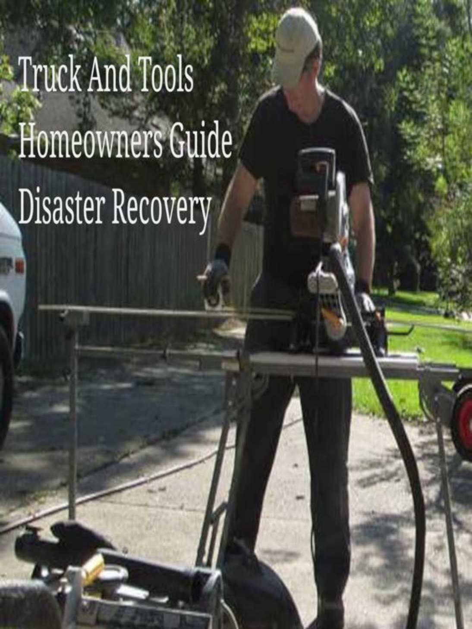

Why is it taking so long to process my HUD CDBG-DR Restore Louisiana Homeowners Grant

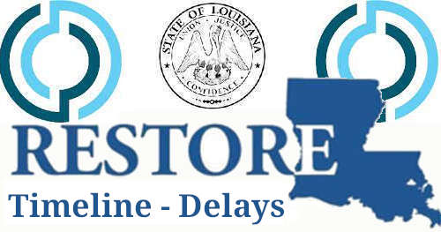

Every federally declared storm has a name and number and your state will make up a new name and number for the branch of government that is responsible for assisting homeowners with their recovery. Same Process, Procedure, People only contractors change.

It will take 7 more days, 14 more days, 2 to 4 weeks, there is no timeline or way to follow the process says one Louisiana Case Worker.

The state office of community development disaster recovery unit consumes millions of federal tax dollars every year to provide you with a logical disaster recovery process and procedure. But the state feels it's best to remodel the process and procedure specific to each disaster which is not procedurally correct and costs more federal tax dollars each year because of it. More administrative costs means less funding to homeowners. Each year homeowners find less funds available and more restrictions in place making the recovery program grant distribution process longer than necessary.

HUD has a program that is called Community Development Block Grant for Disaster Recovery (CDBG-DR) and is funded by allocations approved by congress every year and at times for every disaster.

The state of Louisiana displays simple steps to follow for the HUD CDBG-DR program which Louisiana calls, Restore Louisiana Homeowners Assistance Program or RLHP for short.

The RLHP process step by step.

1. Program Survey
2. Environmental Review
3. Program Application
4. Eligibility Review
5. Damage and Lead Assessment
6. Grant Amount Determination
7. Select Repair Replacement Reconstruction Option
8. Review and Sign HUD Grant Agreement
9. Get scheduled grant reimbursements

Steps 1 through 8 have fixed timelines according to internal state documents related to standard operating procedures of the program. The only way processes 1 through 8 could be delayed would due to the homeowners scheduling or documents.

The process timeline can be calculated all the way to your scheduled reimbursements which is determined on your actual construction or repair activity and progress.

1. Program survey one (1) day, depends on you the applicant.
2. Environmental review could be in 5 to 14 days. It's just a drive by in front of your property.
3. Program application invite typically happens after the Environmental Review has been completed and this process will depend on your properly answering questions as you did in the survey step 1.
4. Eligibility Review takes about 5 business days, ownership, occupancy and income are reviewed. Each request for documents resets the timeline. My advice is to get the correct documents submitted the first time.
5. Damage assessment is scheduled and your lead assessment should be scheduled at the same time but are going to be two different groups of people. This will take 5 to 14 days.
6. Grant amount is then determined with the information collected from the damage assessment. This takes about one week but at times can require additional visits to the property that will day things for at least 5 days for every return visit or request for additional information related to the damage assessment.
7. Selection of how you would like to proceed with your repairs, replacement, construction or reimbursement is a simple task. Most have this figured before the program asks. Takes just minutes for you to submit.
8. Your grant paperwork will be created and then you will be scheduled a time to either sign in person or remotely. Because in person signing is the same as using online document signing you might ask that it be done remotely to speed things along.
9. Now the time is up to what solution you selected and how quickly things work for you with your recovery. You will be given 4 extensions if you request them the first timeline is 180 then extension one will provide you an additional 180 days. After that it's up to the state managers to grant you extensions and they will visit your property to see if you are making progress.

Copyright 2023 TruckAndTools.Com All Rights Reserved.   
Author: Murray Wennerlund   
[Original post location](https://www.truckandtools.com/disaster/declarations/louisiana/default.asp?gdyk=2475)   
Published: 3-28-2023 Revised: 3-28-2023   
[Make a contribution](https://www.truckandtools.com/contribute/default.asp)   
[TruckAndTools.Com](https://www.truckandtools.com/)