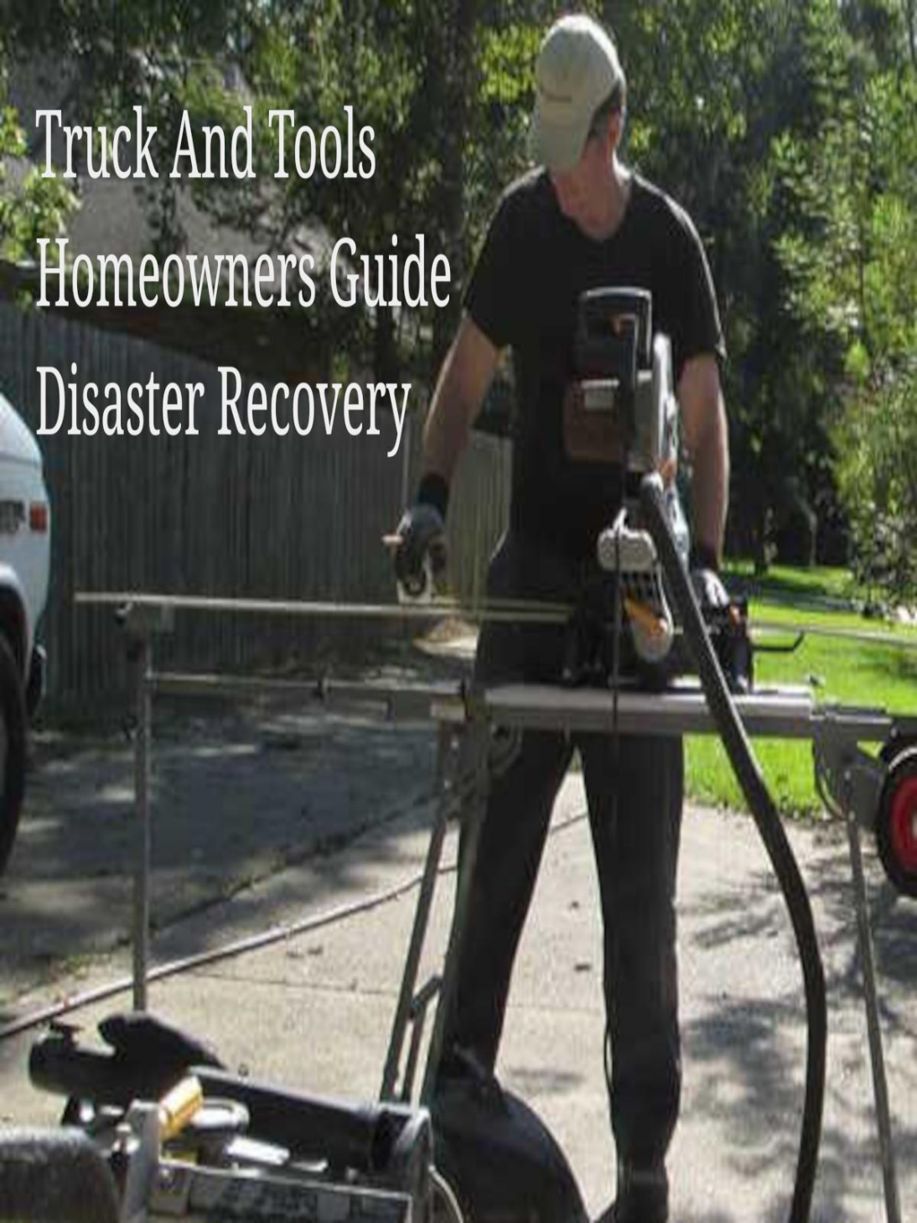

You should not be paying taxes on your disaster damaged home if you do not occupy the home due to the damage.

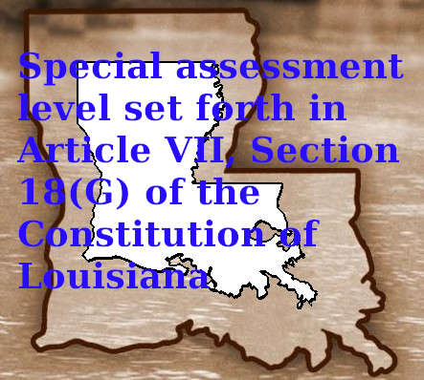

Many Louisiana homeowners simply pay their property taxes as usual even if they are living in a camper on the property while making their primary home safe to occupy after a declared disaster destroyed it. Learn about your tax waivers for your recovery.

[Louisiana Revised Status RS 47:1703](https://legis.la.gov/Legis/law.aspx?d=101333)

Section E.

E. For property damaged during a disaster or emergency, the following shall apply:

(1)(a) Any homestead receiving the homestead exemption that is damaged or destroyed during a disaster or emergency declared by the governor whose owner is unable to occupy the homestead on or before December thirty-first of a calendar year due to such damage or destruction shall be entitled to claim the exemption by filing with the assessor of the parish in which the homestead was located, an annual affidavit of intent to return and reoccupy the homestead within a period of five years from December thirty-first of the tax year in which the disaster occurred. In no event shall more than one homestead exemption extend or apply to any person in this state.

(b) For homesteads qualifying for the homestead exemption under the provisions of this Paragraph, after expiration of the five-year period, the owner of a homestead shall be entitled to claim and keep the exemption for a period not to exceed two additional years by filing an annual affidavit of intent to return and reoccupy the homestead with the assessor within the parish where the homestead is situated. A homeowner shall be eligible for this extension only if the homeowner's damage claim to repair or rebuild the damaged or destroyed homestead is filed and pending in a formal appeal process with any federal, state, or local government agency or program offering grants or assistance for repairing or rebuilding damaged or destroyed homes as a result of the disaster, or if a homeowner has a damage claim filed and pending against the insurer of the property. The assessor shall require the homeowner to provide official documentation from the government agency or program evidencing the homeowner's participation in the formal appeal process or official documentation evidencing the homeowner has a damage claim filed and pending against the insurer of the property.

(c) After expiration of the extension authorized in Subparagraph (b) of this Paragraph, an assessor shall have the authority to grant up to three additional one-year extensions of the homestead exemption on a case-by-case basis. A homeowner shall only be eligible for an additional extension if the owner has made a good faith attempt to secure a contractor or builder to complete the needed repairs or reconstruction of the home but is unable to complete the project due to uncontrollable contractor or builder delays. In order to qualify for this extension, the homeowner shall provide to the assessor documentation evidencing good faith in attempting to secure a contractor or builder to complete the project.

(2)(a) Any owner entitled to the special assessment level set forth in Article VII, Section 18(G) of the Constitution of Louisiana who is unable to occupy the homestead on or before December thirty-first of a future calendar year due to damage or destruction of the homestead caused by a disaster or emergency declared by the governor shall be entitled to keep the special assessment level of the homestead prior to its damage or destruction on the repaired or rebuilt homestead provided the repaired or rebuilt homestead is occupied by the owner within five years from December thirty-first of the year following the disaster. The assessed value of the land and buildings on which the homestead was located prior to its damage shall not be increased above its assessed value immediately prior to the damage or destruction described in this Paragraph. If the property owner receives a homestead exemption on another homestead during the same five-year period, the damaged or destroyed property shall not be entitled to keep the special assessment level, and the land and buildings shall be assessed in that year at the percentage of fair market value set forth in the constitution. In addition, the owner must also maintain the homestead exemption set forth in Article VII, Section 20(A)(10) of the Constitution of Louisiana to qualify for the special assessment level set forth in Article VII, Section 18(G)(5) of the Constitution of Louisiana.

(b) Any owner entitled to the special assessment level as provided for in this Paragraph who is unable to reoccupy his homestead within five years from December thirty-first of the year following the disaster shall be eligible for an extension of the special assessment level on the homestead for a period not to exceed two years. A homeowner shall be eligible for this extension only if the homeowner's damage claim is filed and pending in a formal appeal process with any federal, state, or local government agency or program offering grants or assistance for repairing or rebuilding damaged or destroyed homes as a result of the disaster, or if a homeowner has a damage claim filed and pending against the insurer of the property. The homeowner shall apply for this extension of the special assessment level with the assessor of the parish in which the homestead is located The assessor shall require the homeowner to provide official documentation from the government agency or program evidencing the homeowner's participation in the formal appeal process or official documentation evidencing the homeowner has a damage claim filed and pending against the insurer of the property.

(c) After expiration of the extension authorized in Subparagraph (b) of this Paragraph, an assessor shall have the authority to grant up to three additional one-year extensions of the special assessment level on a case-by-case basis. A homeowner shall only be eligible for an additional extension if the owner has made a good faith attempt to secure a contractor or builder to complete the needed repairs or reconstruction of the home but is unable to complete the project due to uncontrollable contractor or builder delays. In order to qualify for this extension, the homeowner shall provide to the assessor documentation evidencing good faith in attempting to secure a contractor or builder to complete the project.

Research Resource:

* [Louisiana Revised Status RS 47:1703](https://legis.la.gov/Legis/law.aspx?d=101333)

Copyright 2023 TruckAndTools.Com All Rights Reserved.   
Author: Murray Wennerlund   
[Original post location](https://www.truckandtools.com/disaster/declarations/louisiana/default.asp?gdyk=2474)   
Published: 3-2-2023 Revised: 3-12-2023   
[Make a contribution](https://www.truckandtools.com/contribute/default.asp)   
[TruckAndTools.Com](https://www.truckandtools.com/)