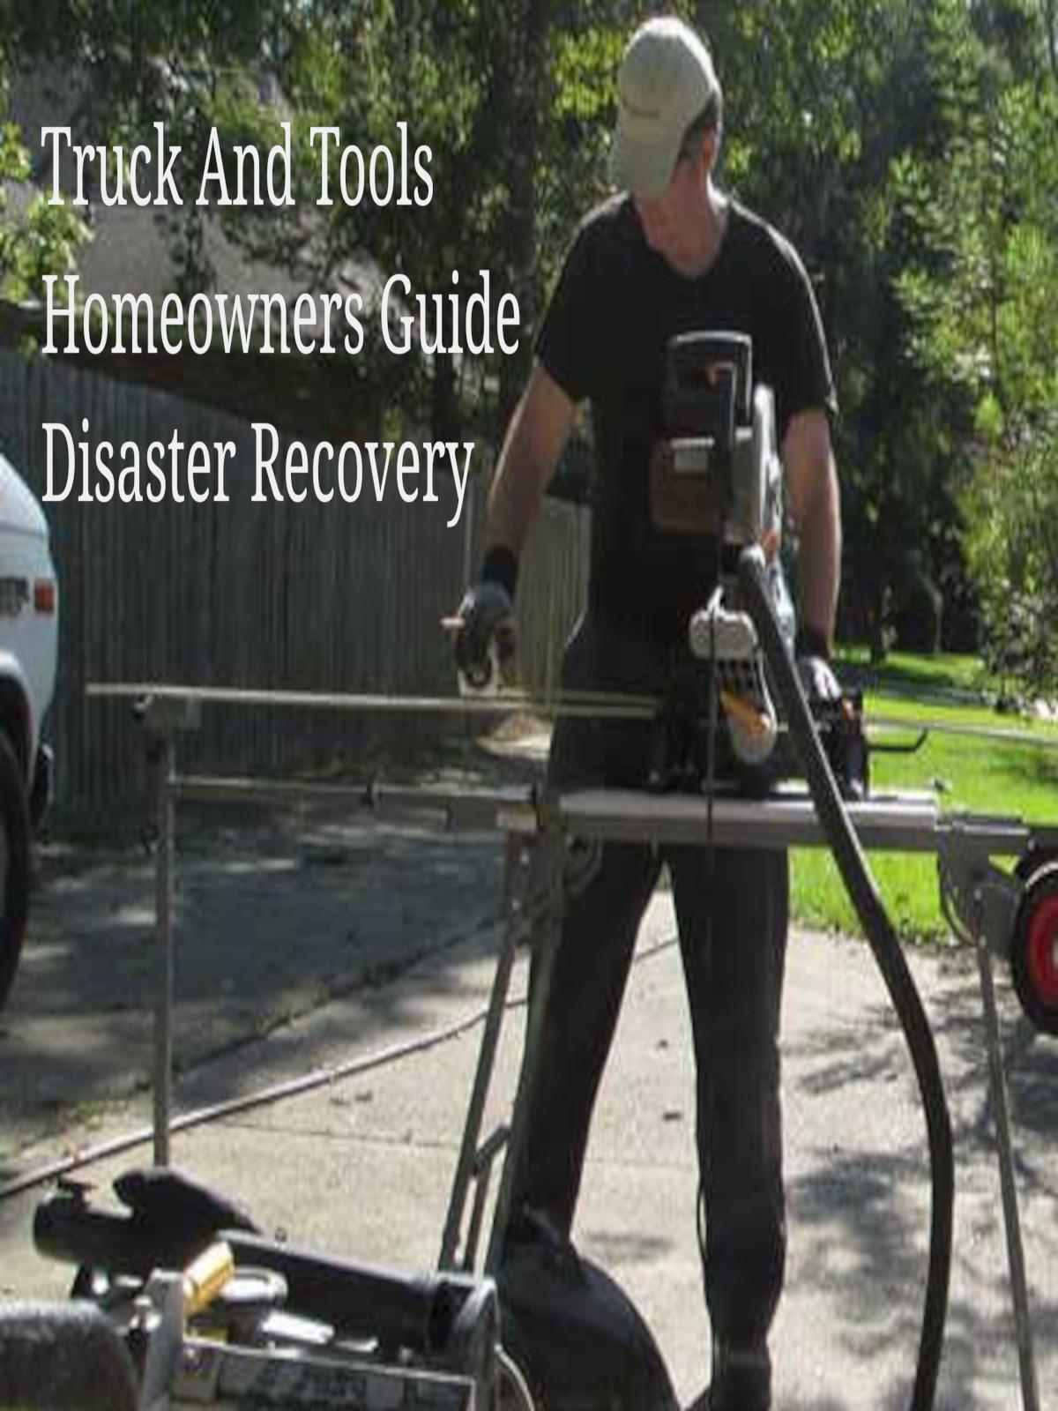

You will be the best homeowner contractor, we know it, you have an eye for quality.

Many homeowners may not realize that being their own contractor can be very rewarding. You never know, you might be able to build your new home for under the $158/sf the contractor bid.

As a homeowner you may think that once you hire a general contractor you worries are over about your home. This is not the case for anyone building their dream home or your children's first home.

You're going to be active with your build, whether it be your design or from your favorite home build as design draftsman you will always have changes and modifications as you make progress with your construction project.

The best way to build a home today is to bring to the table resources that make a difference. When you are in your plan approval phase be sure you have a 3rd party review your plans. Then someone to review your plans for building code, engineering notes, HVAC sizing and ducting, plumbing and electrical. Not to mention all the low-voltage wiring you're going to want in your new home.

You can use any website or social media platform online today to collect information about how things are done. You're always going to find different methods, some good and some not so good. You may never have used your builder and your builder may not have employees that they have worked with. It's an industry that comes with more risk than most realize. You may get everyone that's perfect in the trades and others may get the bottom of the barrel types just looking to keep a crew busy and not interested in a long term relationship with you because you're just a "One Off" to most contractors.

Today we will explore how to search for skilled craftsman and skilled tradesman then find the businesses they own or the businesses they are working for. We first do this by driving around areas that have signs in the front yard or permits in the windows. Take a look, a close look at the permit, it will show the contractors company name or the homeowners name. Stop by and introduce yourself to the contractor or the homeowner and share what you are looking to do at your home.

When you start networking the old fashioned way you may learn very quickly that the actual contractor is hardly ever on the project site. But when you find the main person make sure you talk and get a number or email. Email is best because we really want everything in print, even the simple questions.

Copyright 2023 TruckAndTools.Com All Rights Reserved.   
Author: Writers Pool   
[Original post location](https://www.truckandtools.com/projects/workshop.asp?gdyk=2)   
Published: 11-2-2016 Revised: 3-1-2023   
[Make a contribution](https://www.truckandtools.com/contribute/default.asp)   
[TruckAndTools.Com](https://www.truckandtools.com/)