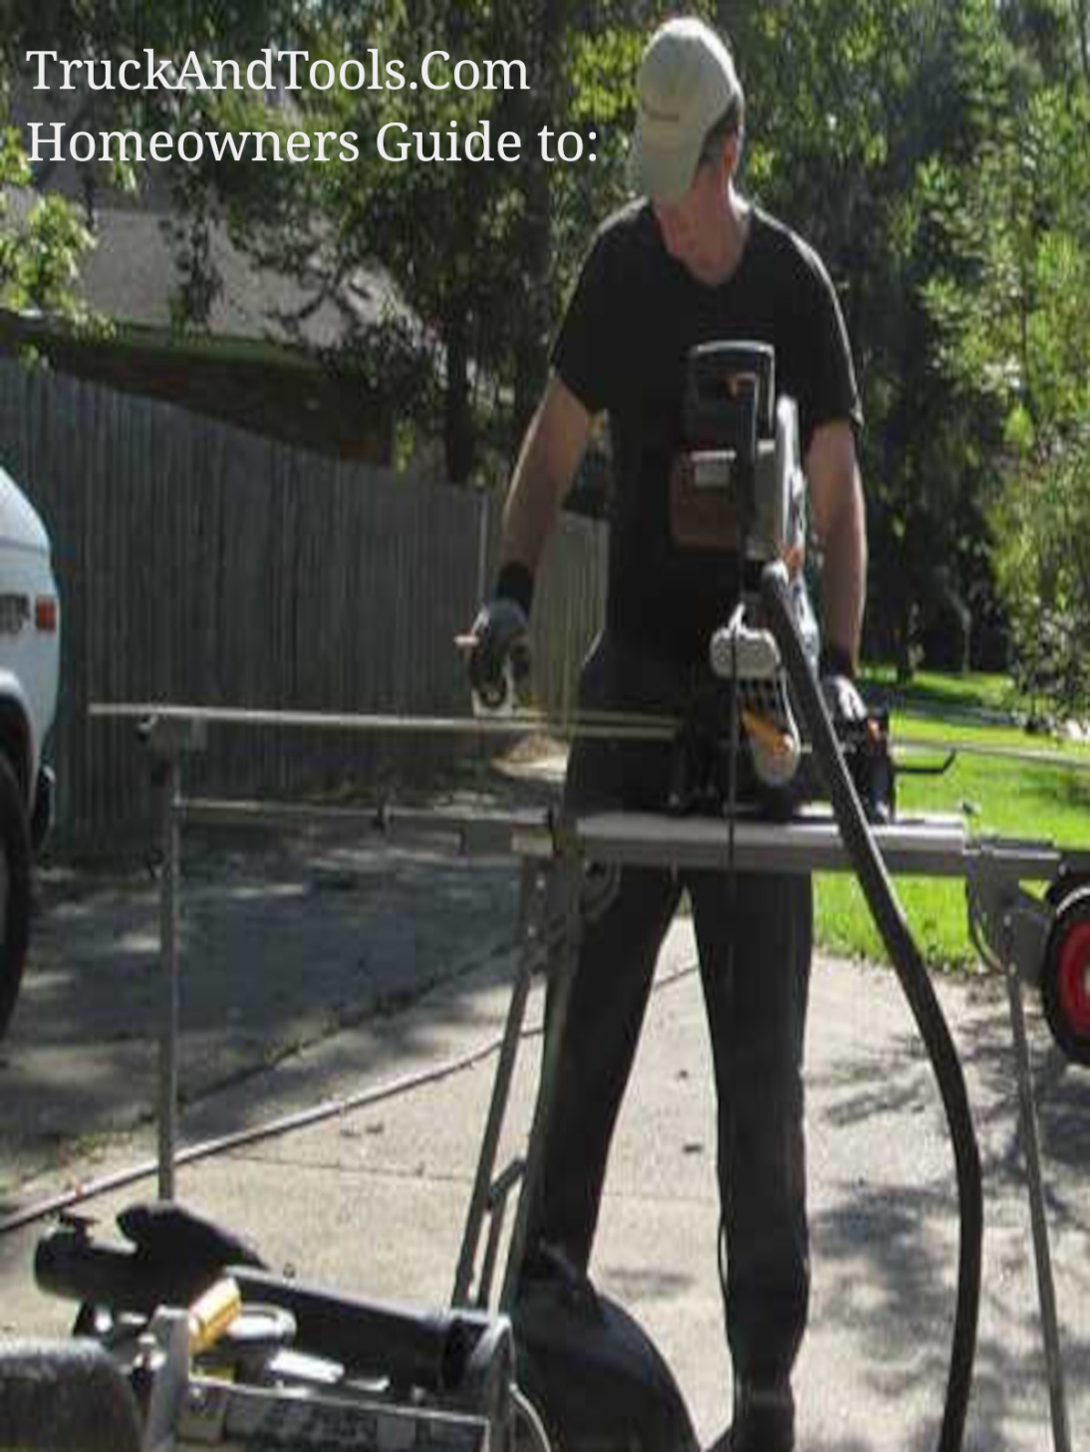
Restore Louisiana OCD-DRU denies homeowners entry to HUD CDBG-DR program because of missing FEMA damage report
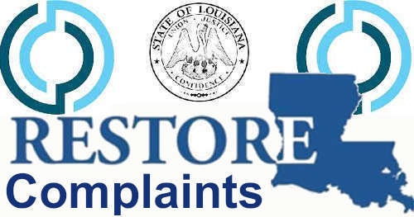
FEMA doesn't inspect all damaged homes after a disaster. They often focus their efforts on most impacted and distressed areas. Often times you can be within the area of a disaster and be the only home on the block that is damaged.

Louisiana Restore Homeowners Program for Hurricanes Delta, Laura, Ida as started sending out your cancellation letters this time by not following HUD training and policy on how to determine your unmet needs assistance by using other resources that estimate your total disaster damages.
Restore LA Email/Letter: "... FEMA inspection was not completed on your property. Per Restore Program requirements, all properties must be determined by FEMA to have major/severe damage."
According to HUD Training the state was informed that the following processes are acceptable when FEMA inspections were not provided to the homeowners.
- Subrecipient’s obligations are as follows:
- For assistance activities, it must be demonstrated that the damage or destruction to structures was a direct result of disaster.
Disaster damage can be documented as follows:
- FEMA, SBA or Insurance award letters.
- In the event that the above-referenced documentation is not available, an inspection report (complete with photos of the damage and a written assessment of the damage) from a damage assessment conducted by a qualified inspector supplied by the subrecipient that certifies that the damage occurred as a result of the disaster will be acceptable.
- In the event that FEMA, SBA or Insurance award letters are not available and an inspection report is inconclusive as to the cause of the damage, the subrecipient may provide alternative evidence, such as neighborhood-level media reports or documentation of damage by disaster response/relief organizations on a case-by-case basis to the DR grantee for review and approval.
- If an applicant was denied assistance by FEMA, assistance through the CDBG Disaster Recovery Program may still be available. Subrecipients are prohibited from refusing housing assistance to applicants solely on the basis that the applicants were denied assistance by FEMA.
The Louisiana Restore Homeowners Program has created an environment that most disaster victims will find very hostile. By not following approved damage inspections provided by HUD CDBG-DR and shared via HUD Exchange training to the state it's clear the state is using the FEMA inspection or nothing approach to limit the number of homeowners the program needs to assist. Similar activity was documented during the 2016 floods where some homeowners who actually flooded did not have FEMA inspections because FEMA selected to limit the inspections to specific geographical areas and where more than one homeowner was impacted.
The information above comes from Homeowner Rehabilitation Program Implementation Tool #2 (attached) published on 11/30/2012, 14:48:00, by ICF who are trainers for the policy and process of CDBG-DR programs.
This was downloaded from HUDExchange.Info https://www.hudexchange.info/programs/cdbg-dr/toolkits/program-implementation/
You will need to start collecting your documentation to file a short appeal over state policy that is different from HUD disaster recovery policy. Then you will need to complete an OIG report and email Region 6 management. I will assist with "How to file an OIG report."
Note, FEMA call centers during the 2020 year were providing "Arm Chair" inspections to which homeowners could document damages and provide pictures. If you still have these pictures and your records you will appeal based on the fact you completed an inspection.

Copyright 2023 TruckAndTools.Com All Rights Reserved.
Author: Murray Wennerlund
Original post location
Published: 10-25-2022 Revised: 4-7-2023
Make a contribution
TruckAndTools.Com

