Cover

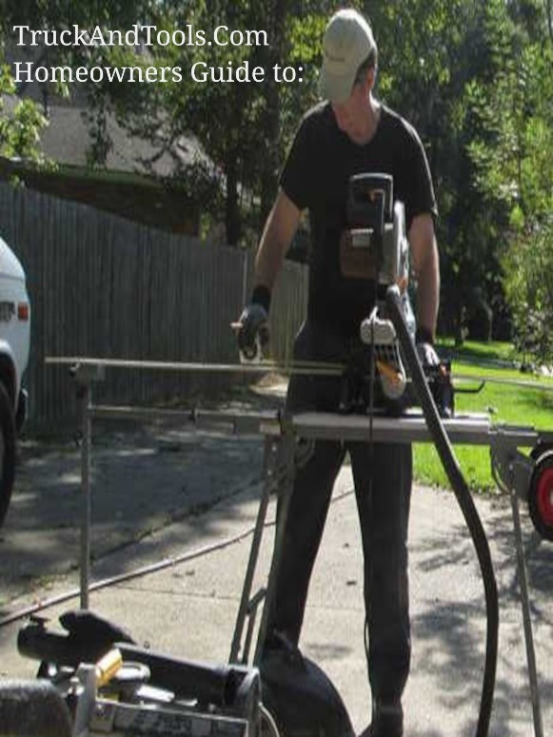

SBA Reconsideration for disaster loan after being denied on the first application processed.

My home was hit by a hurricane Sally. I am in need of an SBA loan to repair my home. I was denied and need to have you reconsider my denied application.



The question posted is a very general and often asked question.

I have many articles in the Disaster Recovery section under SBA as well as in the FAQ section which you can search.

Hurricane Sally hit Alabama September 2020 which means most SBA offerings have ended and all you can do is appeal to either the SBA or FEMA for additional disaster loans or grants.

Because I do not have the denial code or letter detailing (generically) the reason for the denied loan I can only offer general responses.

First of all, if you were denied for any reason you may qualify for additional funds from FEMA. This would include Individual Household Program grants up to $33,500 for repairs of your damaged home. You'll also qualify for Other Needs Assistance (ONA) which is offered to you with a cost share from your state. Typically this is vehicle replacement, repairs of a vehicle, personal property losses. You can ask your states office of emergency preparedness for more details.

Finally, because you are just about 19 months from the disaster date your state should be offering HUD CDBG-DR Grants. HUD Community Development Block Grants for Disaster Recovery are targeted to Low-income to Moderate-income households in the most impacted areas of the disaster. You'll have to check with your state offices to see who is managing the HUD grants for Hurricane Sally.

Here I keep state level information under the menu option Disaster Recovery > State Agency which for Louisiana is called OCD-DRU. It doesn't matter what your state calls it, all states use the same federal policy set by HUD then they individually ask for waivers and changes to HUD policy in the form of action plans and action plan amendments. The program lasts for 6 years starting typically 1 year after the declared disaster.

For Alabama your HUD CDBG-DR Grantee is [Alabama Department of Economic and Community Affairs (ADECA) CDBG – Disaster Recovery linked here](https://adeca.alabama.gov/cdbg-disaster-recovery/) and your direct link to Hurricane Sally Recovery Grants is linked here, [2020 Hurricanes Sally and Zeta CDBG-DR Grant Program .](https://adeca.alabama.gov/cdbg-disaster-recovery/hurricanes-sally-and-zeta/)

Copyright 2022 TruckAndTools.Com All Rights Reserved.   
Author: Murray Wennerlund   
[Original post location](https://www.truckandtools.com/disaster/sba.asp?gdyk=1389)   
Published: 8-27-2022 Revised: 9-4-2022   
[Make a contribution](https://www.truckandtools.com/contribute/default.asp)   
[TruckAndTools.Com](https://www.truckandtools.com/)