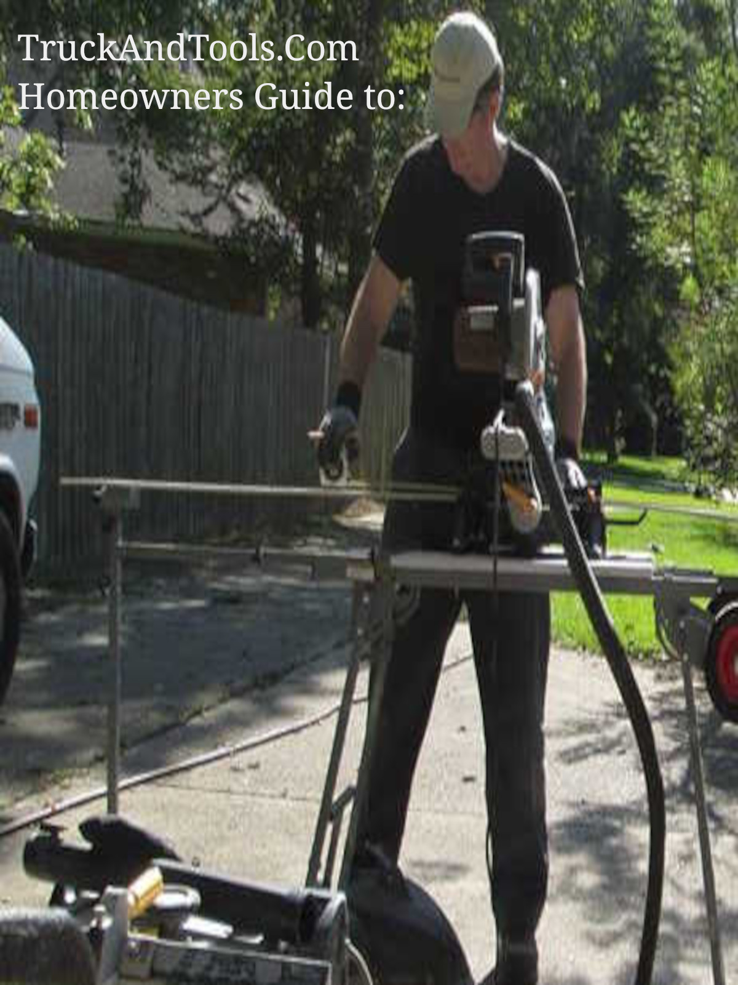

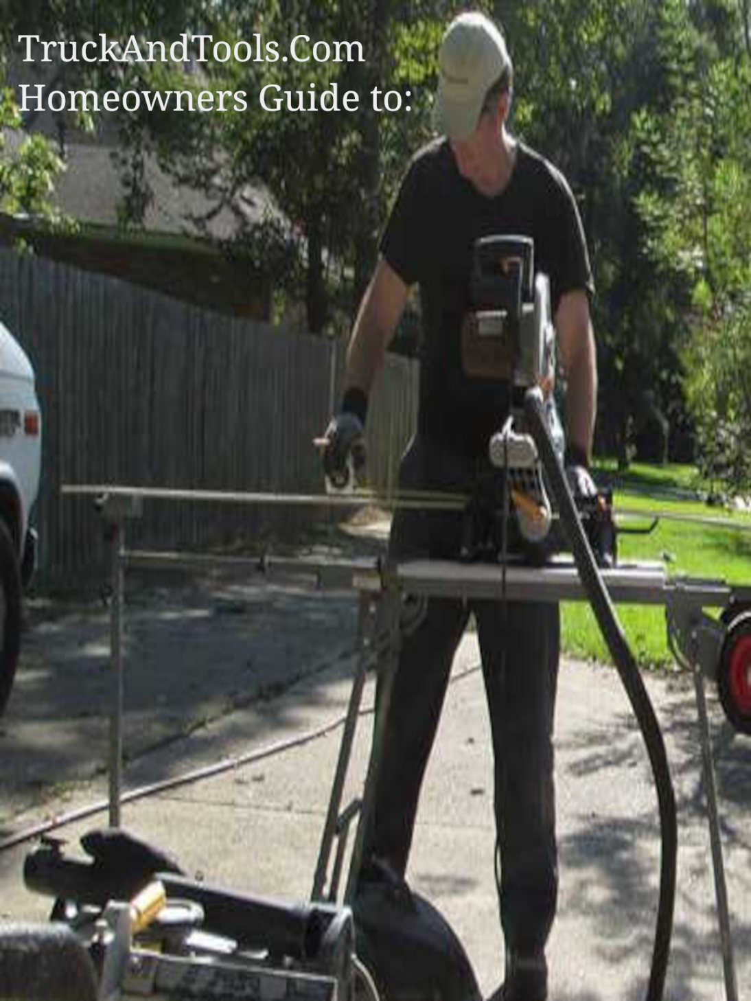

Secured Federal USDA Single Family Housing Repair Loans

Secured Federal USDA Single Family Housing Repair Loans up to 40,000 for 20 years at 1 percent interest and Grants of up to 10,000.



The Section 504 Home Repair program, it provides loans to very-low-income homeowners to repair, improve, or modernize their homes, or provides grants to elderly, very-low-income homeowners to remove health and safety hazards.

[More information about the Section 504 Home Repair loans and grants here.](https://www.rd.usda.gov/programs-services/single-family-housing-programs/single-family-housing-repair-loans-grants/la)

If you are in a disaster zone with an active disaster declaration you should look for HUD CDBG-DR Grants before you look for loans if you are below 100% AMI.

If you must get a loan check with local lenders, local banks for loans not secured by VA, FHA, USDA, SBA, any lender that provides loans not secured by federal tax dollars can be reimbursed in other grant programs such as the HUD CDBG-DR Grant program.

Always research disaster recovery options.

If you are not in a disaster but are very low income make sure the $166 per months for 20 years is affordable today with the inflation rates so high. Do not extend debt burden that will pass to other family members.

Copyright 2022 TruckAndTools.Com All Rights Reserved.   
Author: Murray Wennerlund   
[Original post location](https://www.truckandtools.com/disaster/fema.asp?gdyk=1386)   
Published: 8-25-2022 Revised: 8-25-2022   
[Make a contribution](https://www.truckandtools.com/contribute/default.asp)   
[TruckAndTools.Com](https://www.truckandtools.com/)