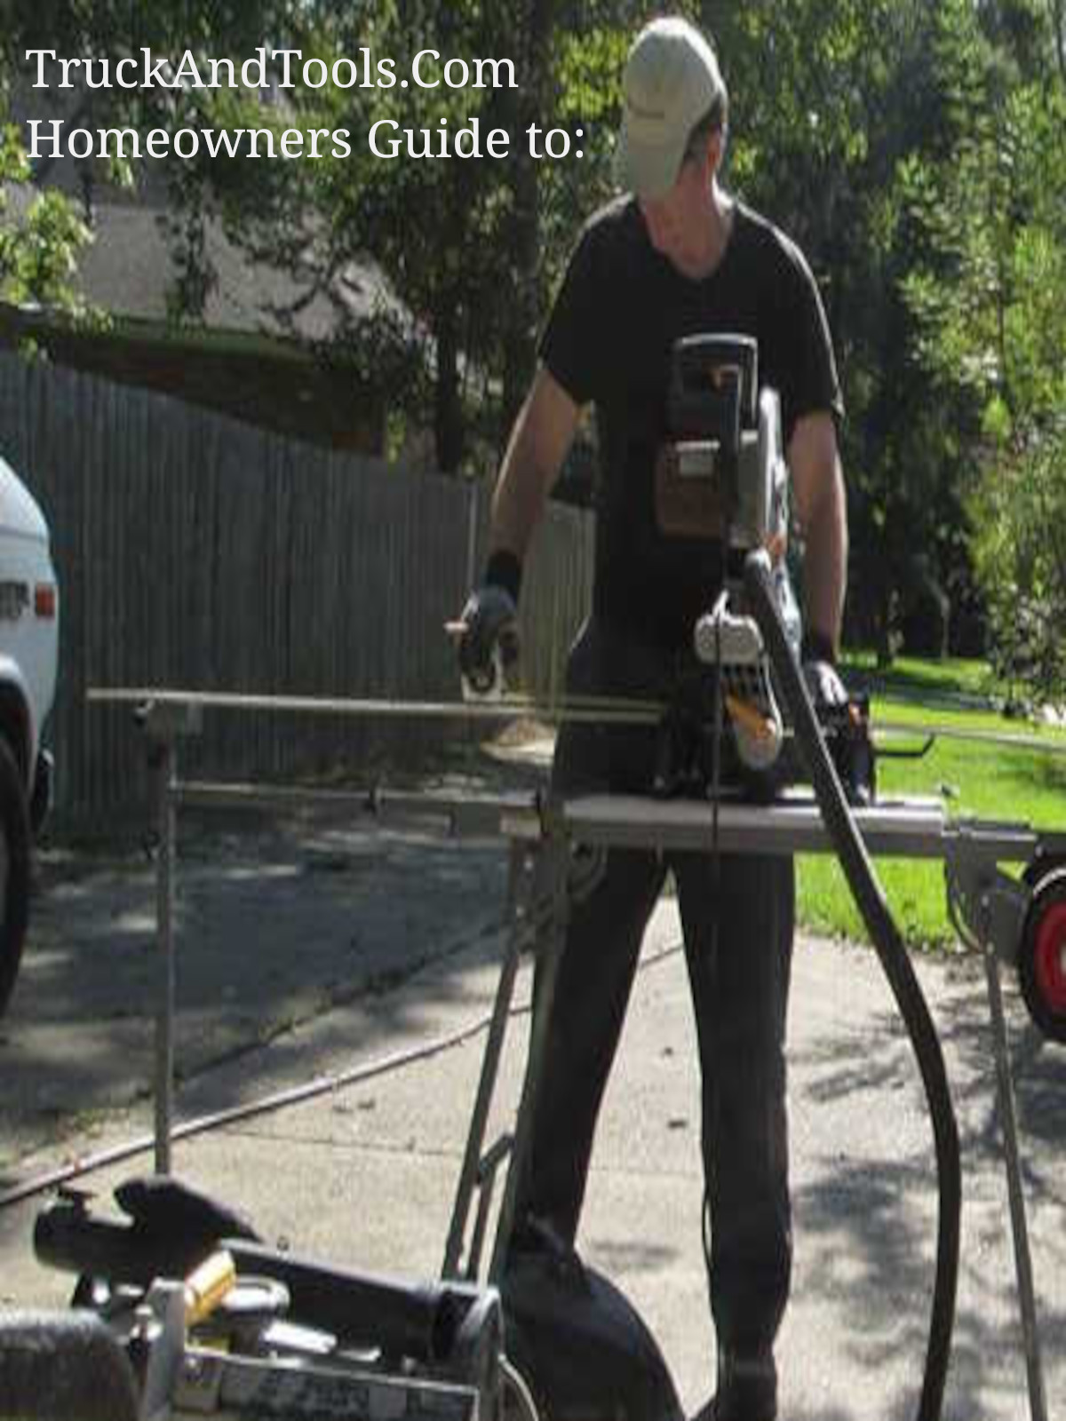

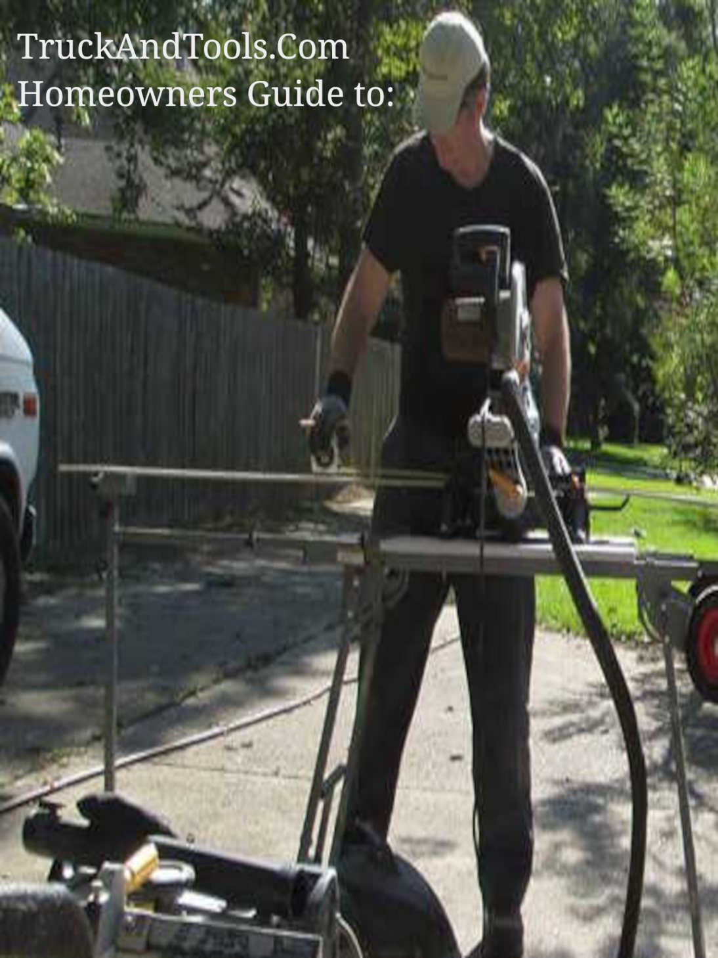

Restore Louisiana Mobile Home MHU Replacement Policy published 7-17-2019

Louisiana has fought over the replacement costs for mobile homes for years. Reimbursement for the total amount has always been the goal but the state of Louisiana OCD-DRU has done everything to not give enough to replace MHUs for safe housing.



Audio

The OCD-DRU published in 2019 the following policy.

PREPARING FOR MHU REPLACEMENT: CHECKLIST

PROGRAM POLICIES

Restore Louisiana's policy is to replace, not rehabilitate/repair, flood-damaged manufactured housing units (MHUs) to best serve the long-term housing needs of flood-affected citizens and protect homeowners from potential environmental health hazards. Water damage to MHUs often results in serious structural and environmental health hazards for occupants of MHUs that may not be effectively remediated with rehabilitation activities. Newer MHUs are built to higher construction standards and offer more energy-efficient options that result in better utility efficiency and lower utility charges.

Program funding can cover the cost for transport, set-up, and site work necessary to install the unit. If the applicant is going to be relocating the MHU to a new location, they must advise their dealer and their Construction Technical Advisor (CTA), as the address will need to be approved by the Program before delivery of the new MHU. If the location is in a Special Flood Hazard Area (SFHA), Program funding may be available to cover the cost of elevation.

PRIOR TO ACCEPTING THE AWARD

Homeowners will be required to submit a copy of the purchase agreement, to be reviewed by a Program CTA, which should include the costs for installation of all of the following services (so that all you have to do is move in:

* Electrical utility connections
* Sewer, gas and water utility connections
* HVAC service
* Elevation costs (if required and/or applicable)

The Program will provide funds for the replacement of single-wide or double-wide damaged units, and the homeowner has complete control over the selection of a new replacement unit. However, the Program advises the homeowner to review the following "Prior to Requesting a Final Inspection" checklist before signing a contract with the MHU dealership to ensure all installation costs are included in the purchase agreement.

PRIOR TO REQUESTING A FINAL INSPECTION

The following items must be in place and functional to pass the final inspection. The program will be unable to issue a check to the homeowner/dealer without a successful final inspection that confirms the following:

* Electricity turned on
* Water, gas and sewer connected and tied-in to local utilities
* AC delivered and installed
* Front and back steps in place to access the MHU

If the new manufactured home will be located in a SFHA, the MHU must be elevated to two feet above the Base Flood Elevation as measured from the top of the finished floor. A copy of a post elevation certificate and proof of flood insurance will be required

Research Resource:

* [Restore-LA-Preparing-MHU-Replacement-Assistance-7-17-19.pdf](https://cdnrestorela.s3.us-west-2.amazonaws.com/wp-content/uploads/2019/07/17093528/Restore-LA-Preparing-MHU-Replacement-Assistance-7-17-19.pdf)

Related Articles:

* [State of Louisiana may be offering $85k to $100K in grants for substantially damaged manufactured homes.](https://www.truckandtools.com/disaster/mur.asp?gdyk=1384)

Copyright 2022 TruckAndTools.Com All Rights Reserved.   
Author: Murray Wennerlund   
[Original post location](https://www.truckandtools.com/disaster/ocd_dru.asp?gdyk=1368)   
Published: 5-17-2022 Revised: 8-25-2022   
[Make a contribution](https://www.truckandtools.com/contribute/default.asp)   
[TruckAndTools.Com](https://www.truckandtools.com/)